Rev 7/2012 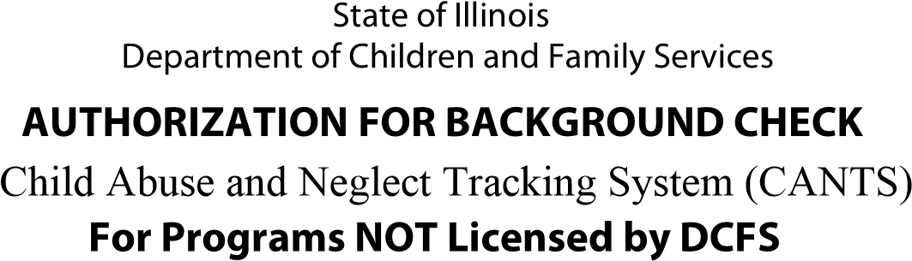
NOTE: Do not use this form if you are an applicant for licensure or an employee/volunteer of a licensed child care facility. Please contact your licensing representative.
Male
Female
Gender:
Street/Apt #
Date of Birth:
--
--
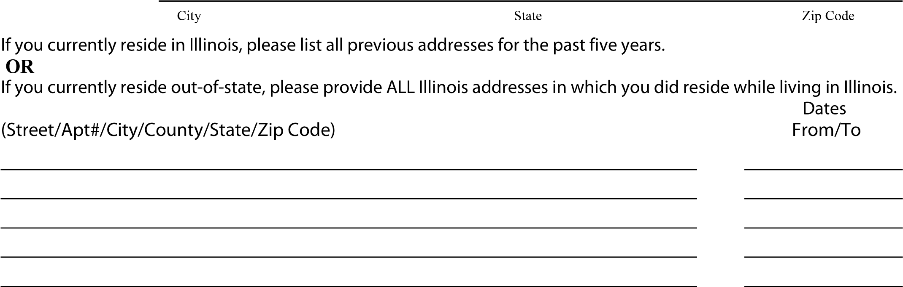
List maiden name and/or all other names by which you have been known: (last, first, middle)

I hereby authorize the Illinois Department of Children and Family Services to conduct a search of the Child Abuse and Neglect Tracking system (CANTS) to determine whether I have been a perpetrator of an indicated incident of child abuse and/or neglect or involved in a pending investigation. I further consent to the release of this information to the agency listed below.
